OOPs PROJECT

ON

HOSPITAL MANAGEMENT SYSTEM

INDEX

|  |  |  |
| --- | --- | --- |
| S. No. | Title | Page No. |
| 1. | Problem Statement | 3 |
| 2. | Solution | 4 |
| 3. | Objective | 5 |
| 4. | Concepts Used | 6-7 |
| 5. | Pseudo Code | 8-13 |
| 6. | Snippets from program | 14-22 |
| 7. | UML | 23-29 |
| 8. | Programming Code | 29 |
| 9. | Conclusion | 30 |

**Problem Statement:**

A hospital is a health care institution providing patient treatment with specialized medical and nursing staff and medical equipment. But management in hospitals is really a hectic work. Hospitals have to maintain registers for all the data of patients, about their registrations, bills, reports, and all the data of doctors. These data are prone to damage and finding and maintaining data is another headache for hospital. Not only hospitals but patients also have to go a lot of trouble while going to hospital for treatment.

Given below are the problems faced by hospitals, patients and doctors:

* **Lack of immediate retrievals: -**

The information is very difficult to retrieve and to find particular information like- E.g. - To find out about the patient’s history, the user has to go through various registers. This may results in inconvenience and wastage of time.

* **Lack of immediate information storage: -**

The information generated by various transactions takes time and efforts to be stored at right place.

* **Lack of prompt updating: -**

Various changes to information like patient details or immunization details of child are difficult to make as paper work is involved.

* **Error prone manual calculation: -**

Manual calculations are error prone and take a lot of time this may result in incorrect information. For example calculation of patient’s bill based on various treatments.

* **Preparation of accurate and prompt reports: -**

This becomes a difficult task as information is difficult to collect from various register.

And the list of problems keep on going. So how do we solve these problems?

**Solution:**

The solution to the above mentioned problems is a Hospital Management System.The purpose of the project entitled as “HOSPITAL MANAGEMENT SYSTEM” is to computerize the Management of Hospital to develop software which is user friendly, simple, fast, and cost effective. It deals with the collection of patient’s information, diagnosis details, etc. Traditionally, it was done manually. The main function of the system is register and store patient details and doctor details and retrieve these details as and when required, and also to manipulate these details. The Hospital Management System can be entered using a username and password.

**Objective:**

1. Define hospital
2. Register the incoming patient and store his information
3. Generating bills
4. Record reports of patient
5. Application approval of incoming doctor
6. Store the data of doctor like fees, appointments and requests
7. Access to patient and doctor’s details for administration
8. Adding of reports and bills of patients by administration
9. Access to remove doctor from hospital by administration

**Concepts Used:**

**All the code is written in Java language and for storing data MySQL database is used.**

**Packages**

There are four packages namely, Main Package, Patient Package, Doctor Package, Administration Package.

**Interface**

Driver and Connection interfaces are used in database connection.

**Inheritance**

Many classes will extend other classes to make use of same tasks or for generalization.

**Class**

All the code for each window is written in different classes and are interlinked.

**Constructors**

Each class has one more constructors to initialize the objects of class.

**Exception Handling**

Exceptions are handled over the code to handle run time errors.

**Functions of type static and non-static**

To perform various operations functions are used, which are either static or non-static depending upon the need.

**Overloading of functions and constructors**

At certain places functions and constructors are overloaded to successfully implement operations.

**Multithreading**

Various classes are running at the same time, jumping from one window to another, making use of multithreading.

**String handling**

All the data displayed or taken as input is handle using string objects.

**Swing (GUI)**

The output of program is show in the form of GUI, which is implemented using Swing Class of Java.

**JDBC (Java Database Connectivity)**

We have used JDBC to connect our code to database to store and retrieve data as and when required.

**Database (MySQL)**

We have used MySQL as our database, storing our data in tables.

**Pseudo Code:**

**package** HospitalManagementSystem;

//starting page

**public** **class** HomePage {

**int** userType;

//1-Patient

//2-Doctor

//3-Administration

**void** callUser(**int** userType)

{

//calls user according to the type selected

//login page open from here

}

}

//user login page

**class** LoginUser {

String userName;

**private** String password;

**void** login(String userName, String password)

{

/*

if(credentials matched)

calls the user profile object

else

message about the wrong credentials and return to login page

*/

}

**void** newRegister()

{

/*

calls the registration object according to the user type

*/

}

**void** cancel()

{

/*

return call back to HomePage

*/

}

}

//registration of new user

**class** Registration {

String name;

**private** String password;

**char** gender;

String dob;

String email;

String contact;

**void** register()

{

/*

input all the details of the user and create username and password

save all the details of user

*/

}

**void** cancel()

{

/*

return call back to LoginUser

*/

}

}

//common user details and functions

**class** UserDetails {

String name;

**private** String password;

**char** gender;

String dob;

String email;

String contact;

**void** viewProfile()

{

/*

user can view all his/her personal details

*/

}

**void** editProfile()

{

/*

user can edit his/her some details such as contact number, email, dob

*/

}

**void** logout()

{

/*

return call back to LoginUser

*/

}

}

--------------------------------------------------------------------------------------------------------------------------------------

**package** HospitalManagementSystem.Patient;

**import** HospitalManagementSystem.*;

**class** RegisterPatient **extends** Registration {

String[] bloodgroup = {"A+ve", "A-ve", "B+ve", "B-ve", "AB+ve", "AB-ve", "O+ve", "O-ve"};

String address;

}

**public** **class** Patient **extends** UserDetails {

String bloodGroup;

String address;

**void** viewReports()

{

/*

patient can see all his/her reports

*/

}

**void** viewBills()

{

/*

patient can see his/her bills, dues and amount paid

access Bills with patientId

*/

}

**void** payBills()

{

/*

patient can pay his/her dues

store data in Bills object

*/

}

**void** appointments()

{

/*

patient can see all the upcoming appointments they have

patient can even book appointments

if(new appointment to be booked)

call the appointment object

*/

}

}

**class** Appointments {

String[] doctor = {"name1", "name2" , "namez"};

String[] meetType = {"virtual meet", "physical meet"};

String date;

String symptoms;

**void** bookNow()

{

/*

book the appointment for patient with any doctor

*/

}

**void** cancel()

{

/*

return call back to Patient class

*/

}

**void** accept()

{

/*

doctor can accept appointment of patient and it will reflect back to patient profile

*/

}

**void** reject()

{

/*

doctor can reject appointment of patient and it will remove the appointment

*/

}

}

**class** Bills {

String id;

String patientId;

**long** amount;

**long** amountPaid;

**long** amountDue;

String date;

}

**class** Reports {

String id;

String patientId;

String reportType;

**void** downloadReport()

{

/*

patient can download the reports

*/

}

}

----------------------------------------------------------------------------------

**package** HospitalManagementSystem.Doctor;

**import** HospitalManagementSystem.*;

//when doctor registers then the application will be sent to admin

**class** RegisterDoctor **extends** Registration {

String licenseNo;

String specialization;

String qualification;

//override register function to send application

**void** register()

{

/*

input all the details of the user and create username and password

save all the details of user

sends application to administration

*/

}

}

**public** **class** Doctor **extends** UserDetails {

String licenseNo;

String specialization;

String qualification;

**void** appointments()

{

/*

doctor can view all the appointments that he/she has to attend

*/

}

**void** requests()

{

/*

doctor can view all the appointment requests

he/she can either accept or reject the requests

*/

}

}

--------------------------------------------------------------------------------------------------------------------------------------

**package** HospitalManagementSystem.Administration;

**import** HospitalManagementSystem.*;

**public** **class** Admin **extends** UserDetails {

String skills;

**void** viewPatients()

{

/*

admin can see all the details of patients

*/

}

**void** addReports()

{

/*

admin can add reports of patients that will reflect on patient's profile

*/

}

**void** addBills()

{

/*

admin can add bills of patients that will reflect on patient's profile

*/

}

**void** viewDoctors()

{

/*

admin can see all the details of doctors

*/

}

**void** deleteDoctors()

{

/*

admin can delete doctor from hospital

*/

}

**void** application()

{

/*

admin can see all the applications of doctors

admin can either accept or reject application

call Application object's functions

*/

}

}

**class** Application **extends** RegisterDoctor {

**void** accept()

{

/*

admin can accept the application by calling this function

*/

}

**void** reject()

{

/*

admin can reject the application by calling this function

*/

}

}

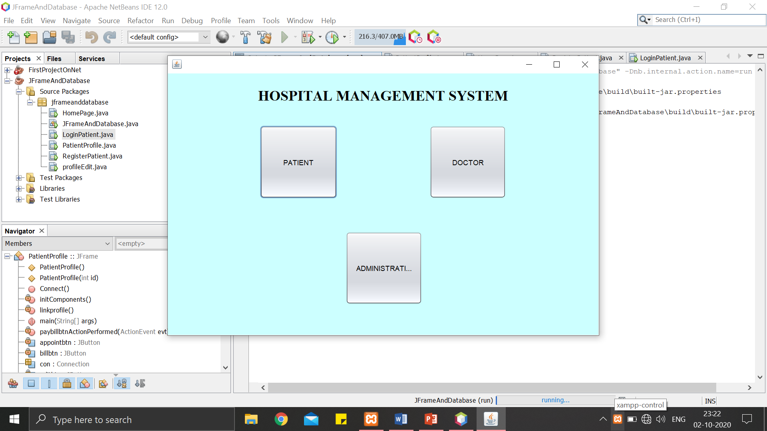**Snippets from program:**

Figure 1: Home Page

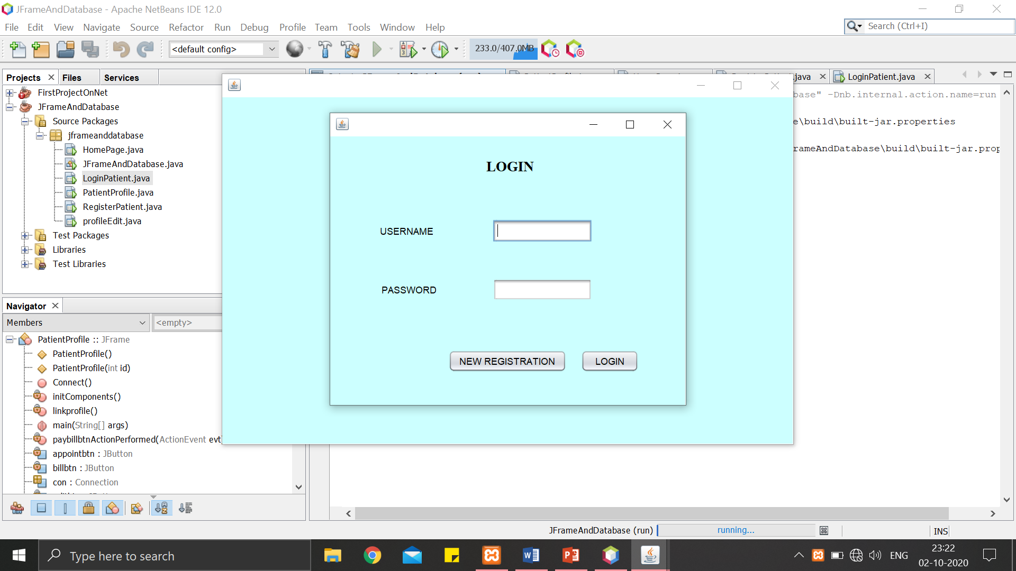

Figure : Login Page

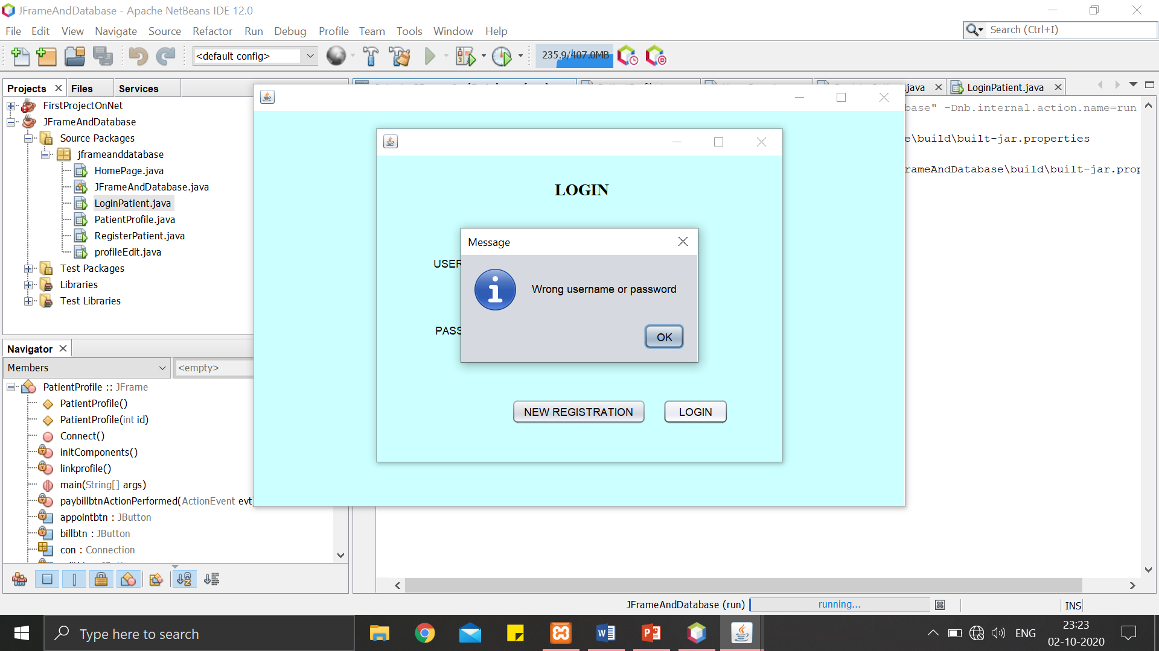

Figure : Pop message when entered wrong credentials

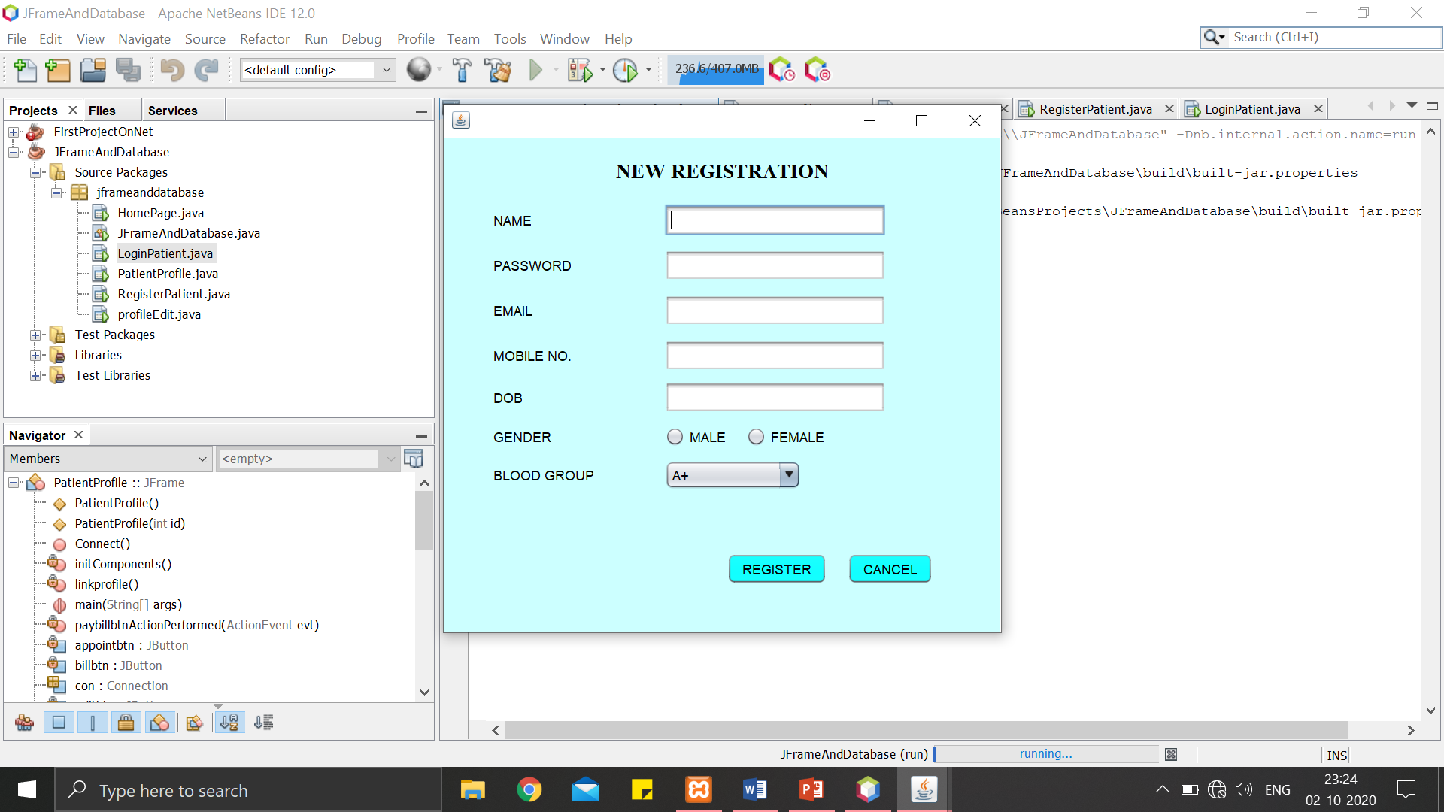

Figure : Registration Page (Patient)

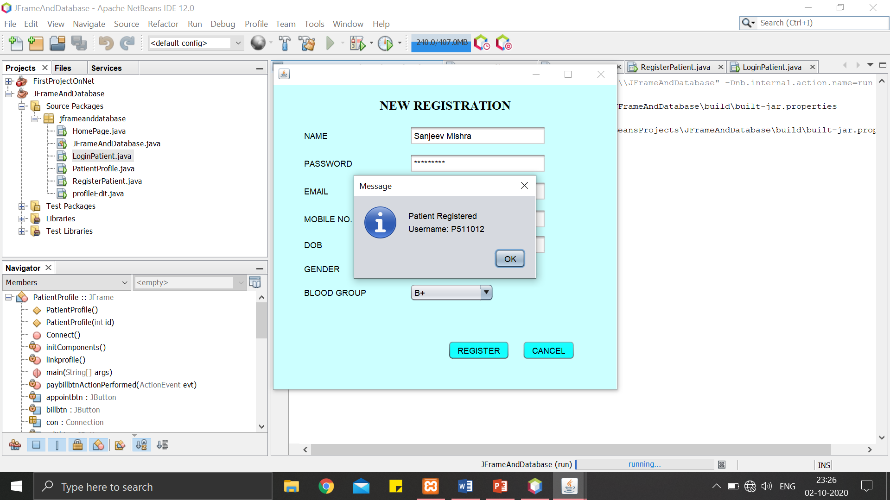

Figure : Pop message upon registration displaying generated username

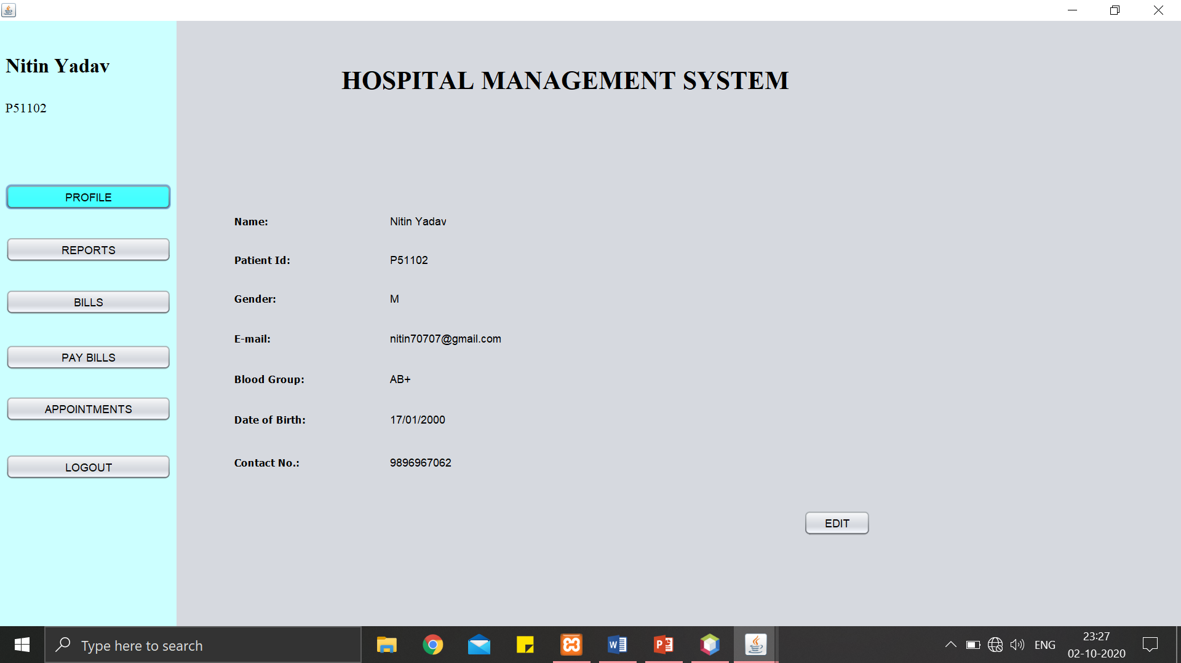

Figure : Patient’s Profile (opened upon login)

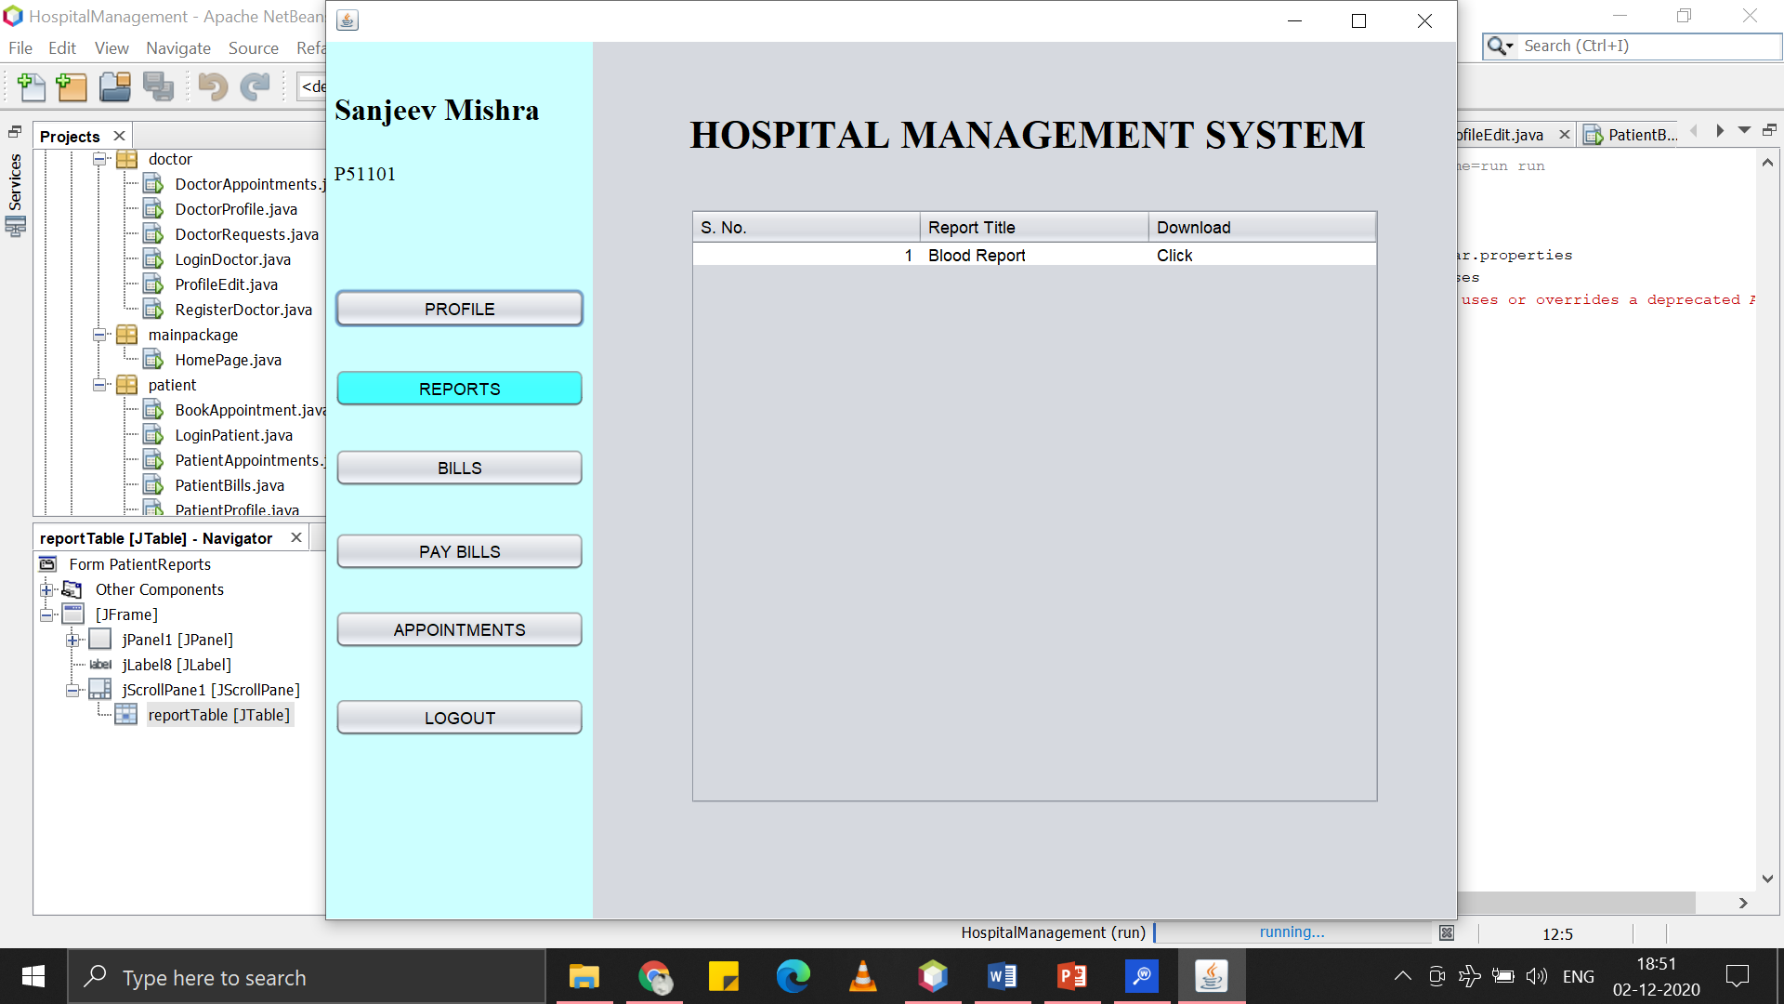

Figure : Reports of patient (will reflect when admin adds them)

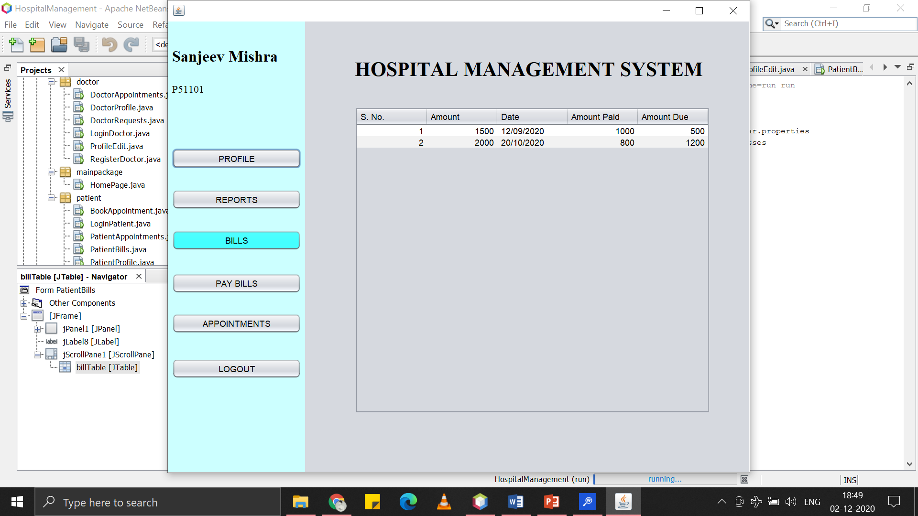

Figure : Bills of patient (will reflect when admin adds bills)

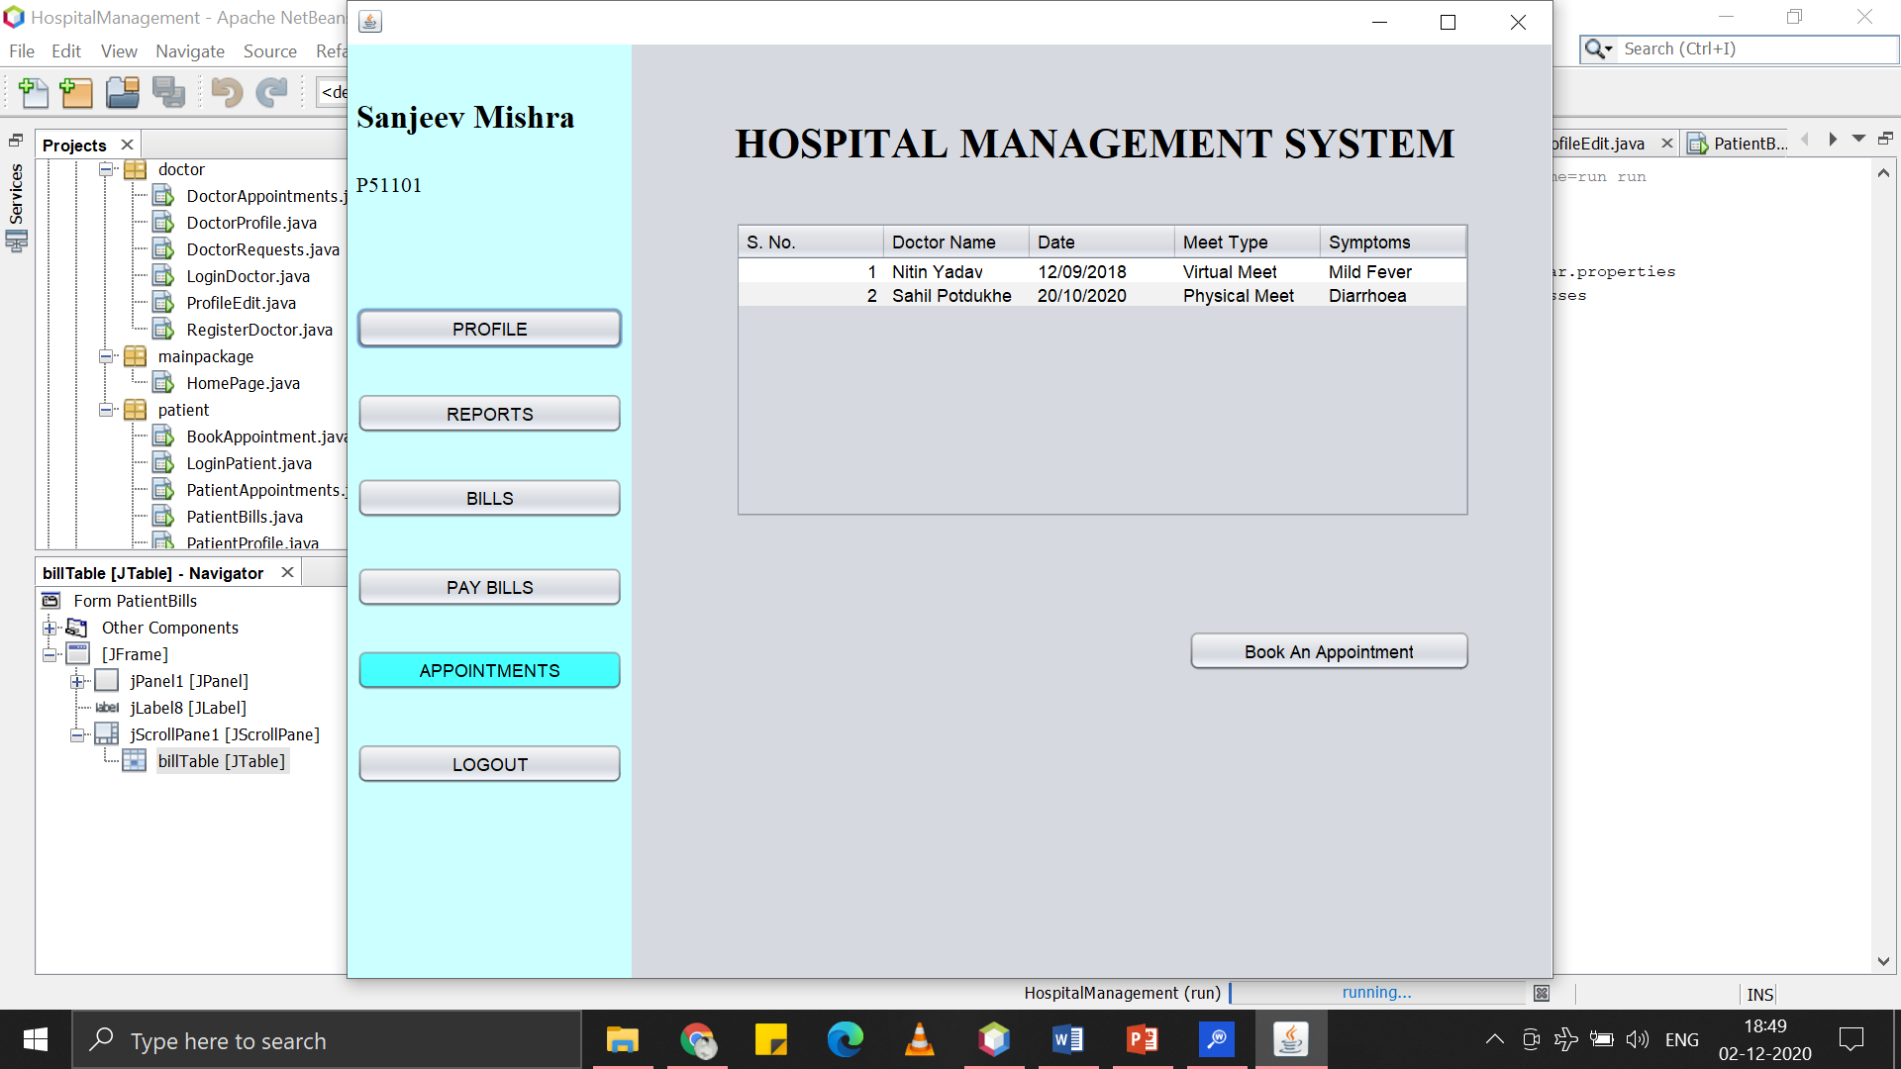

Figure : Appointments of patient (will reflect when booked an appointment)

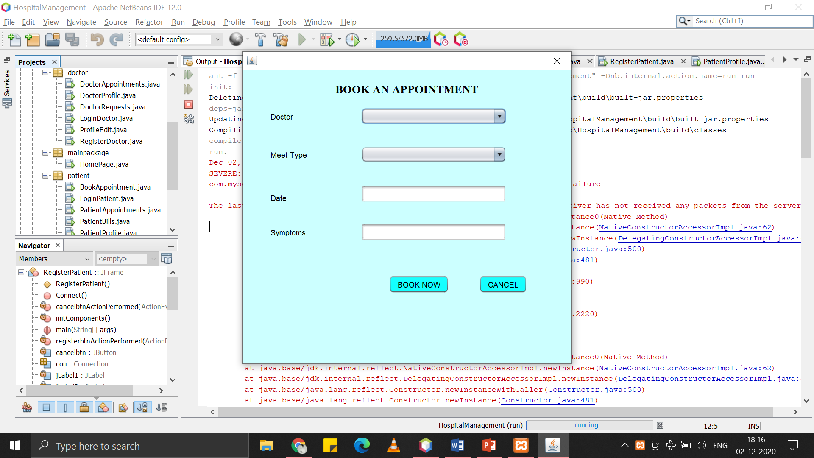

Figure : Book an appointment

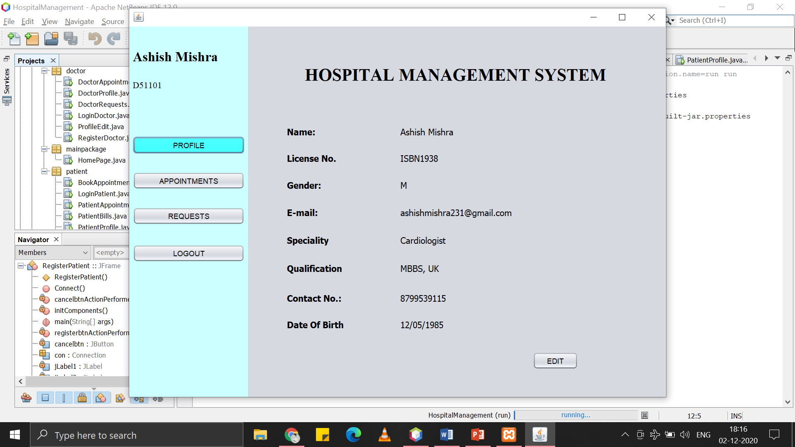

Figure : Doctor's Profile

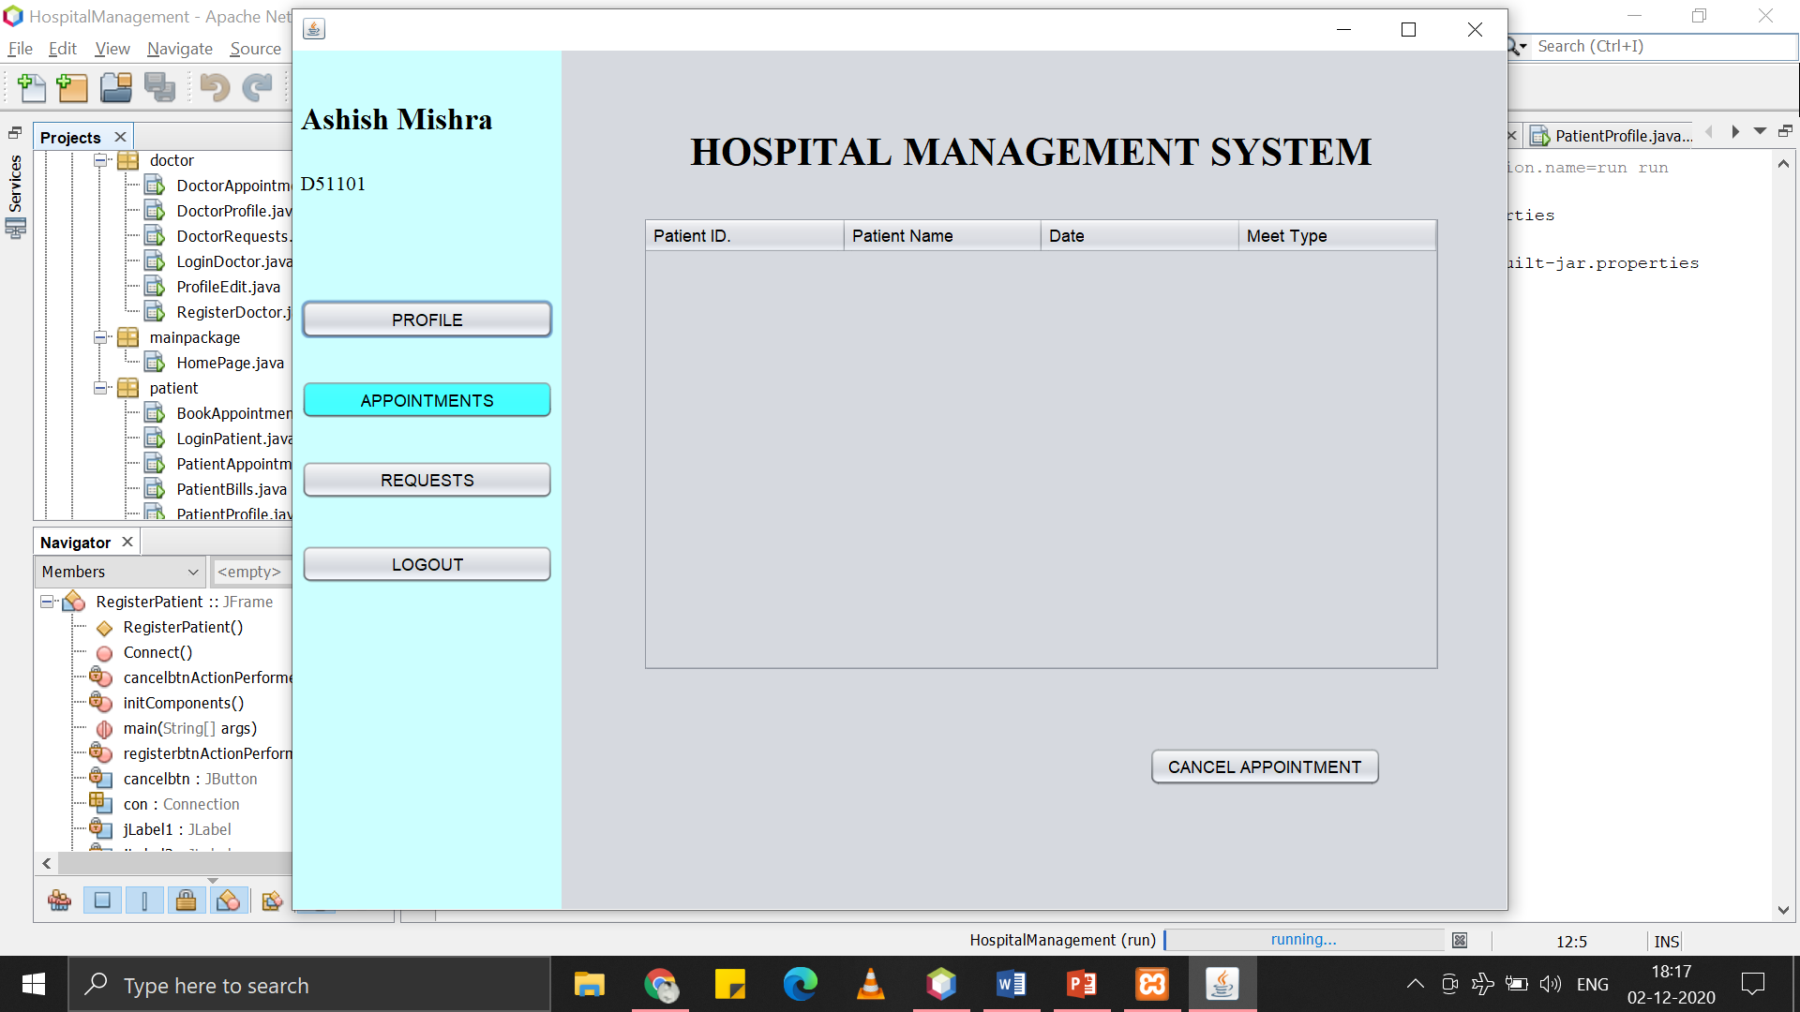

Figure : Appointments of doctor booked by patients (can cancel)

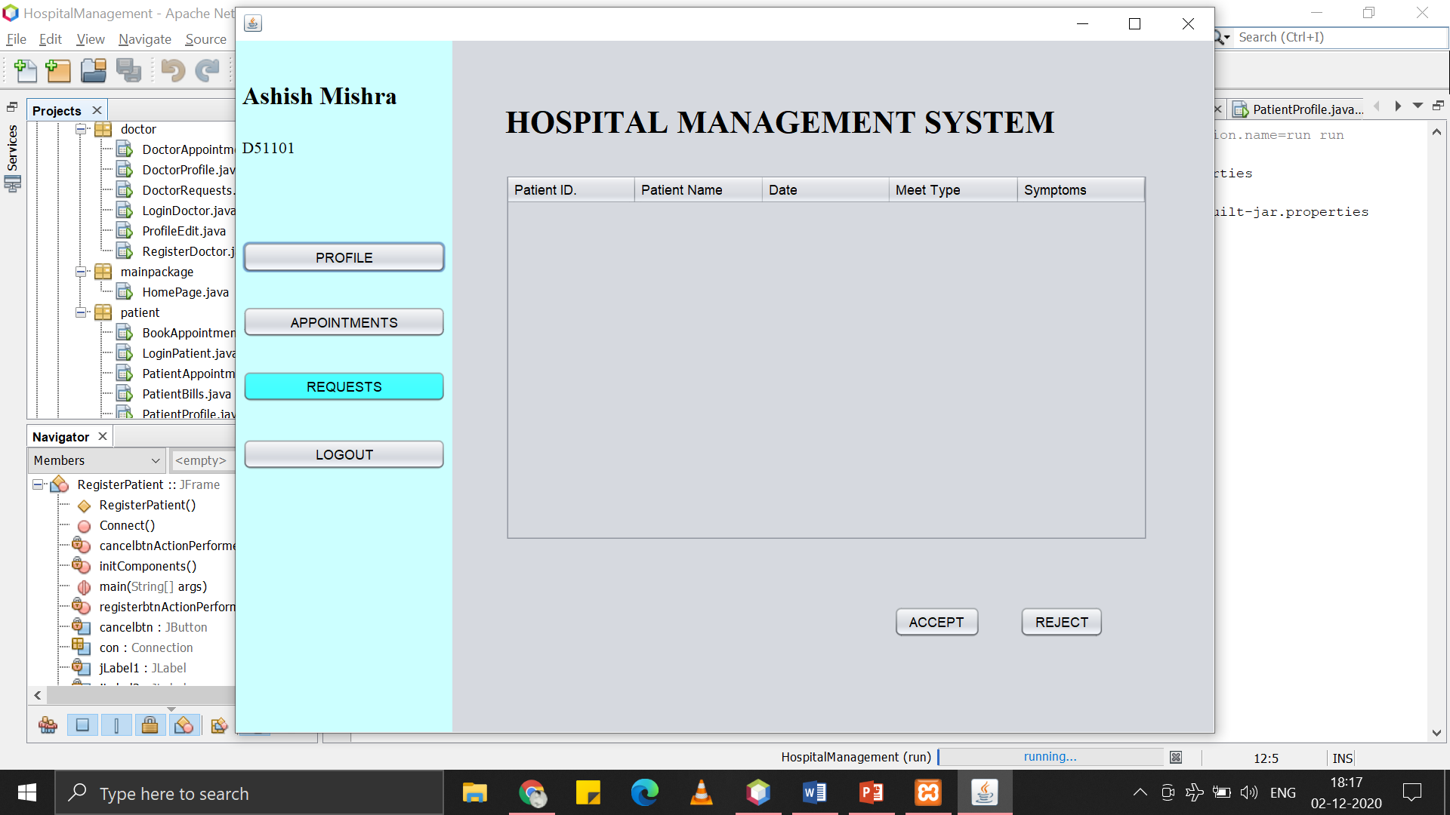

Figure : Appointment Requests (with option to accept and reject)

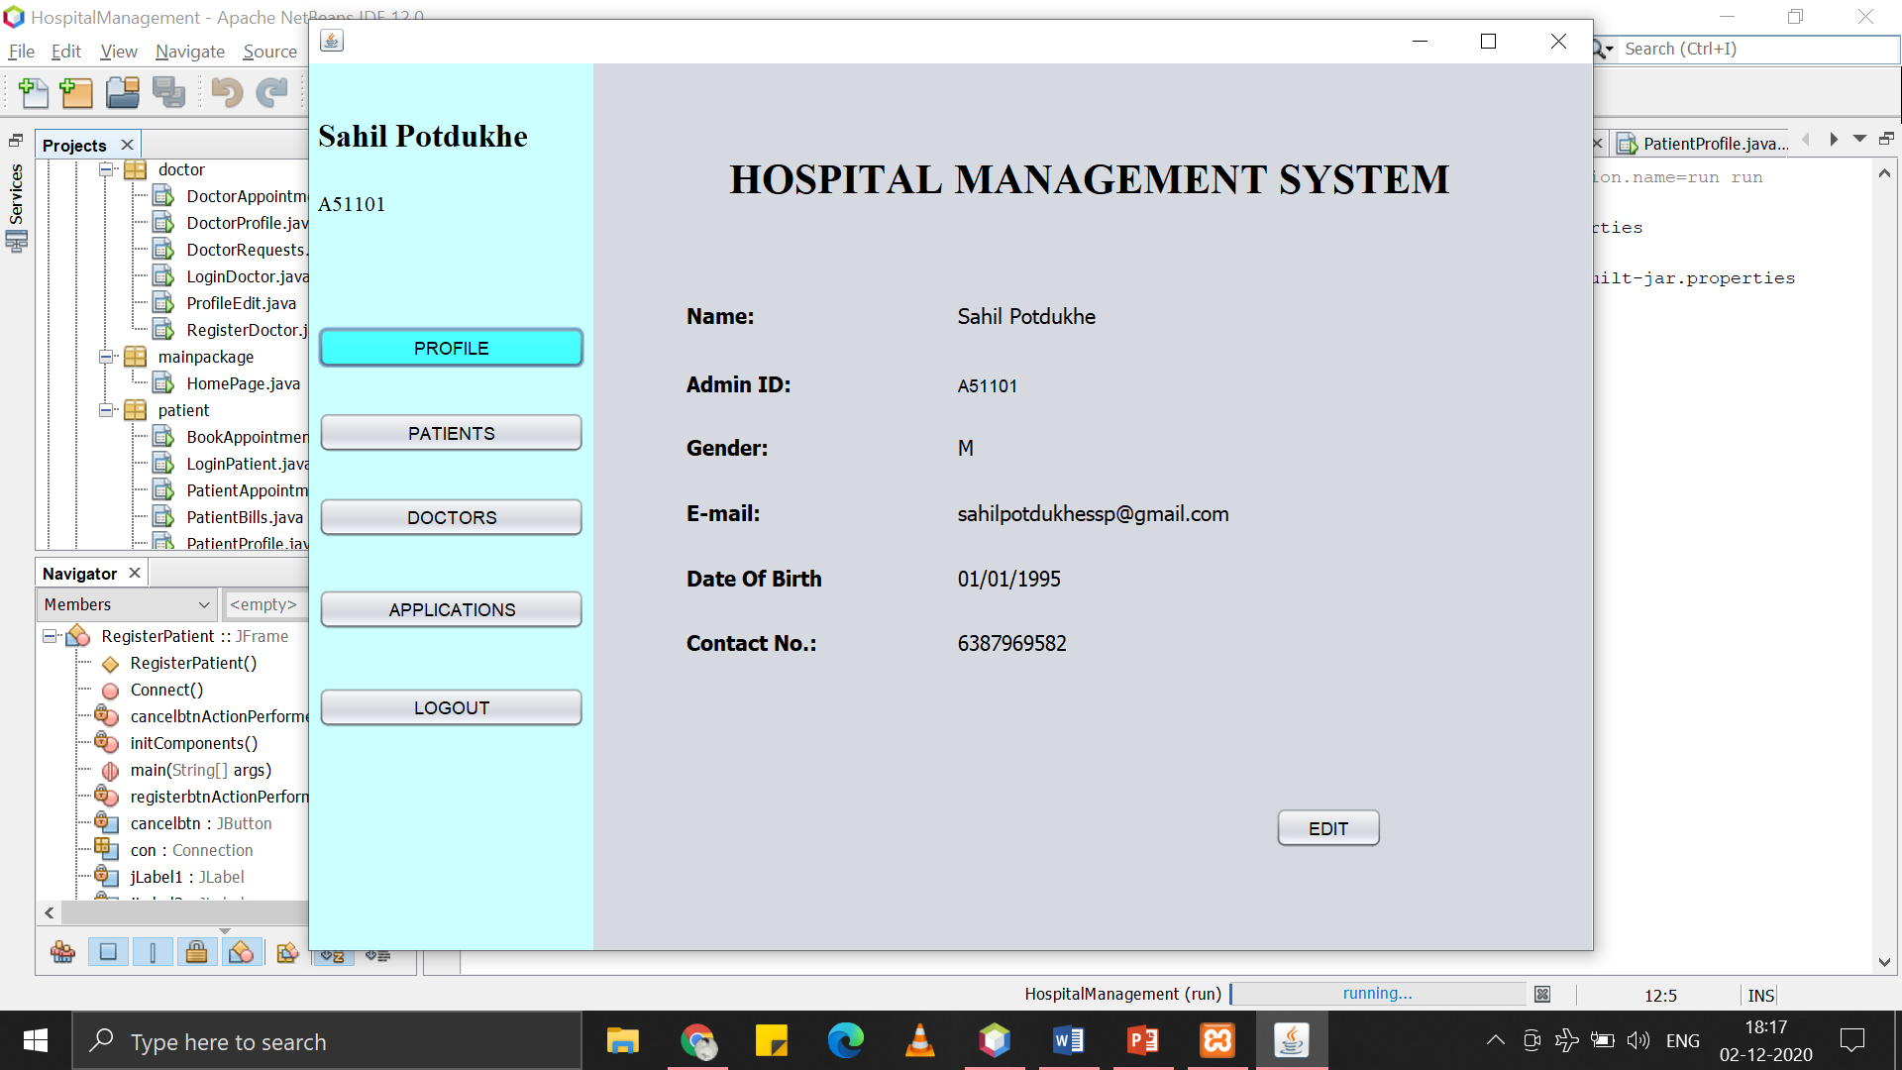

Figure : Admin Profile

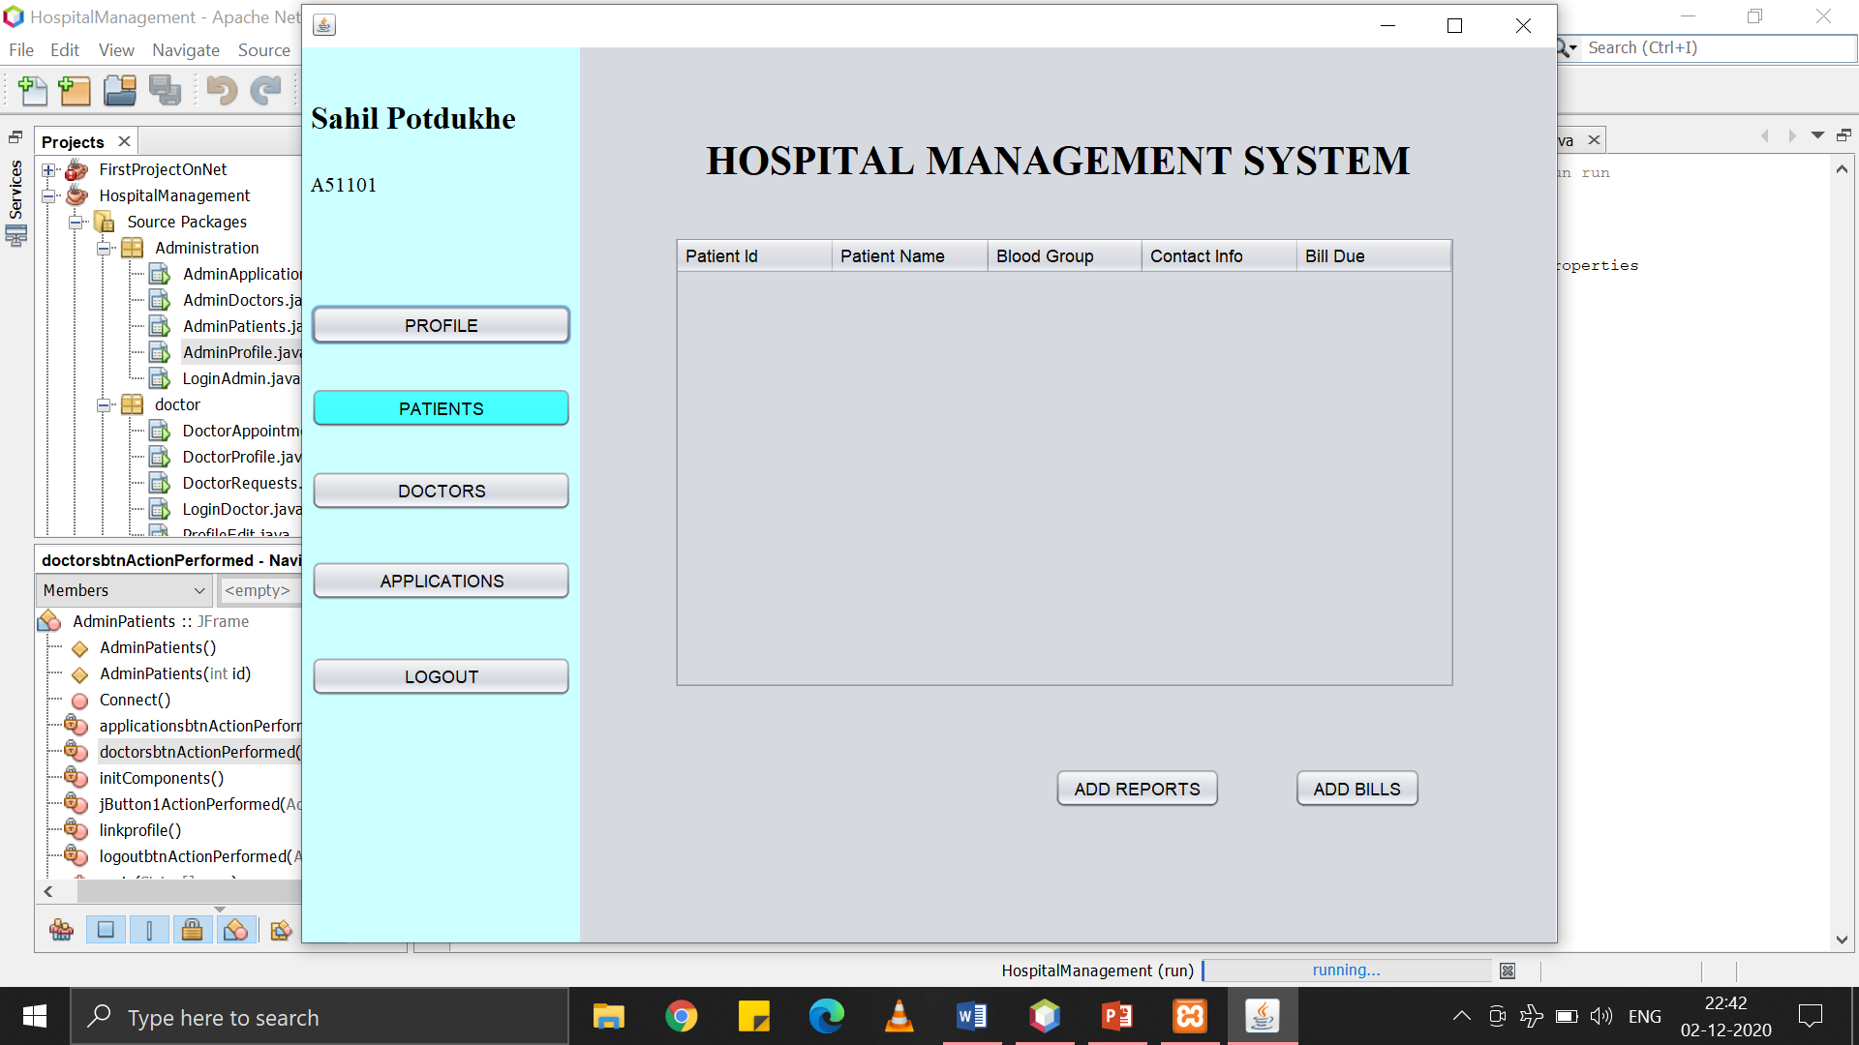

Figure : Patients Details (will reflect when patients are added)

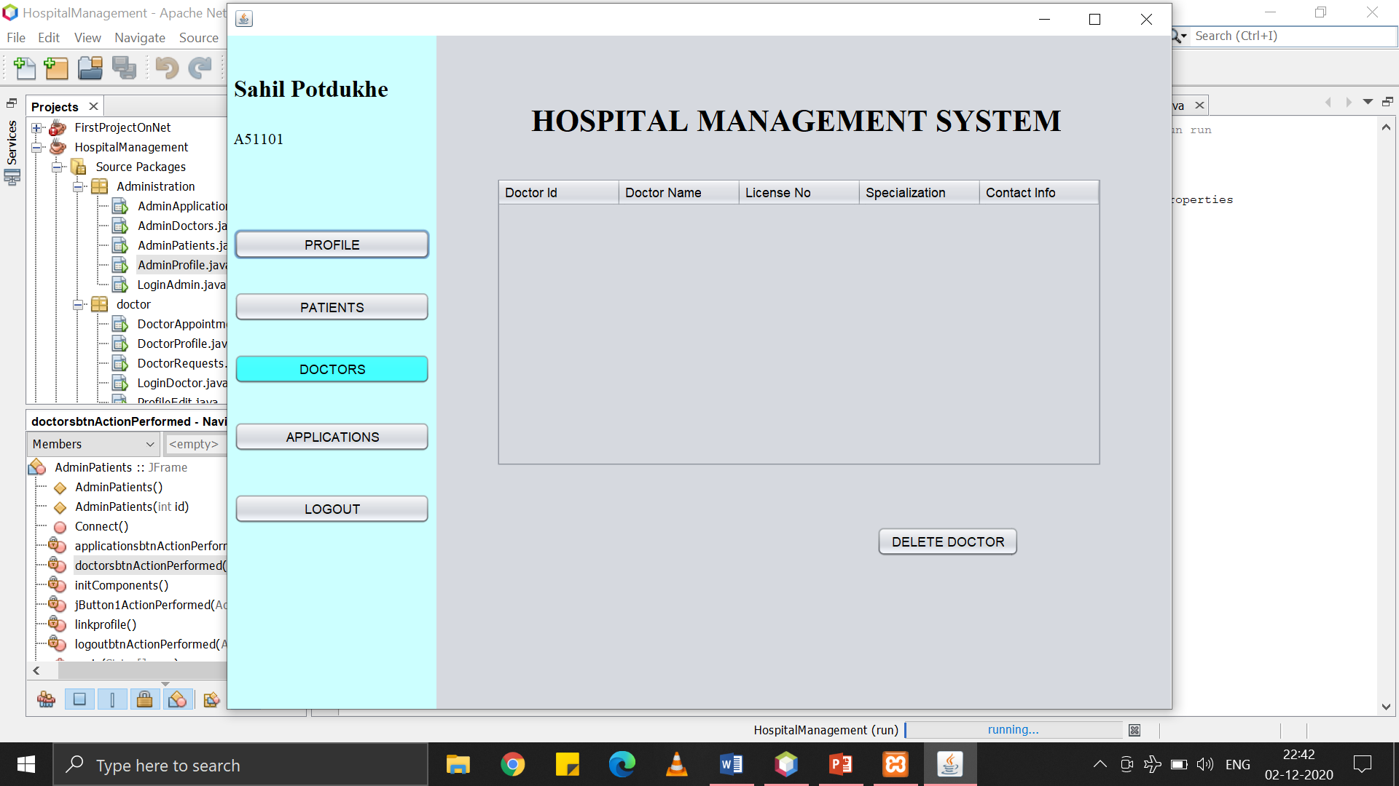

Figure : Doctors Details (will reflect when doctors are added)

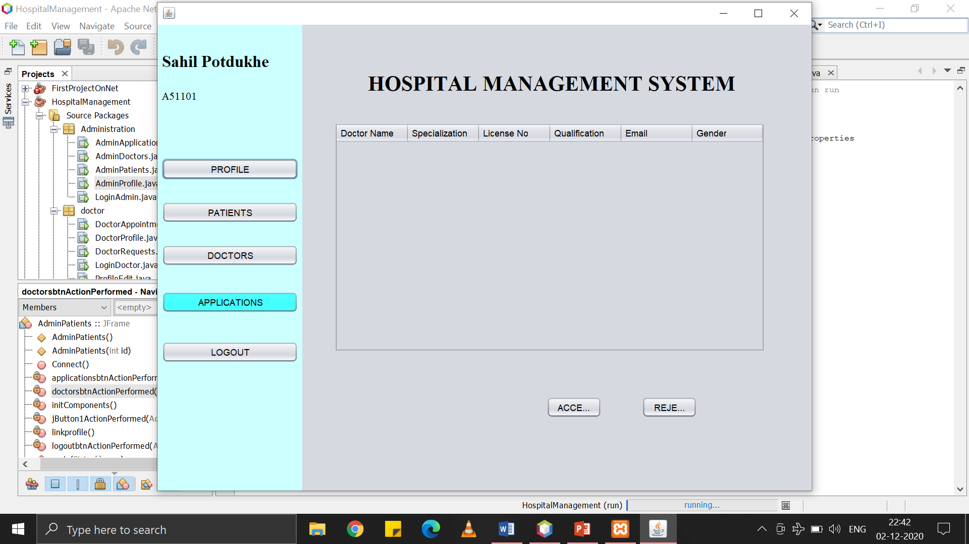

Figure : Applications of Doctors(will reflect when doctors will register)

**UML:**

1. Class diagram

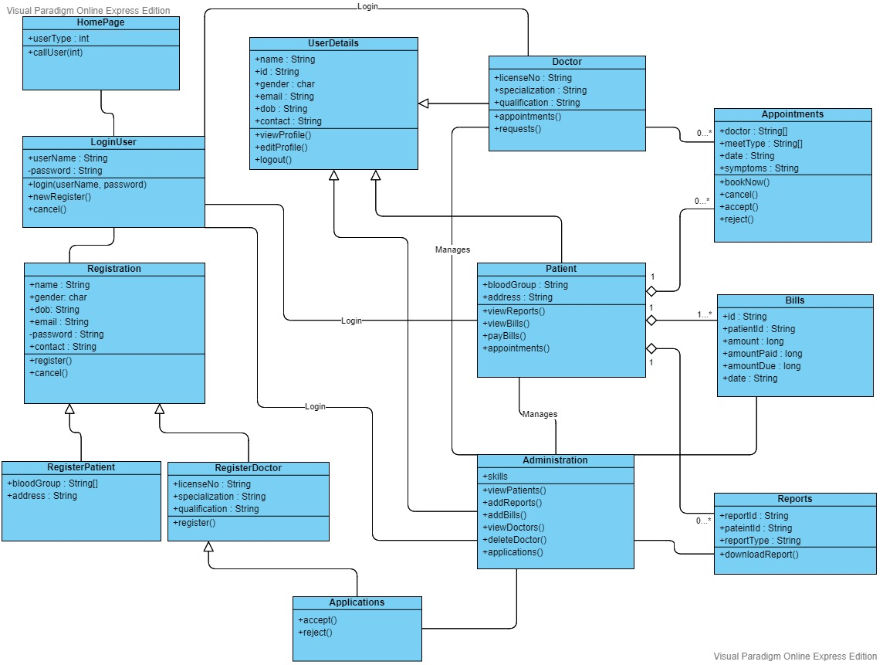

1. Sequence Diagram (Patient)

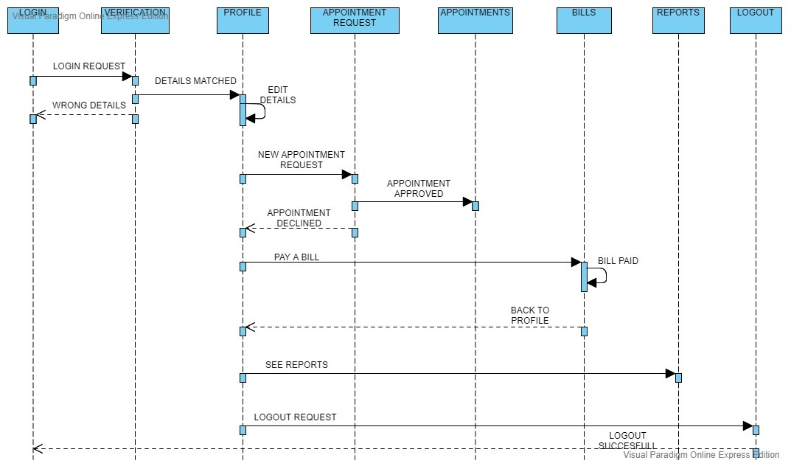

1. Sequence Diagram (Doctor)

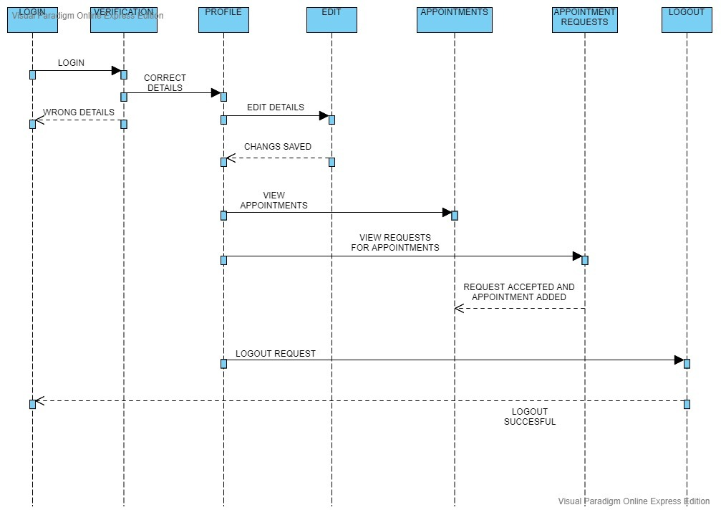

1. Sequence Diagram (Administration)

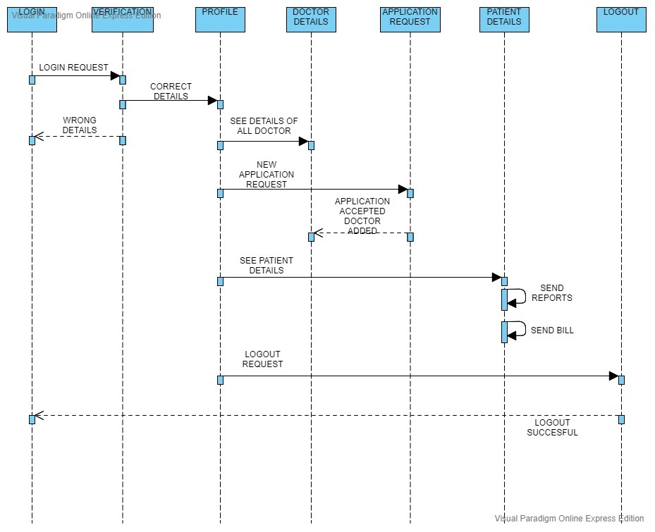

1. Activity Diagram (Patient)

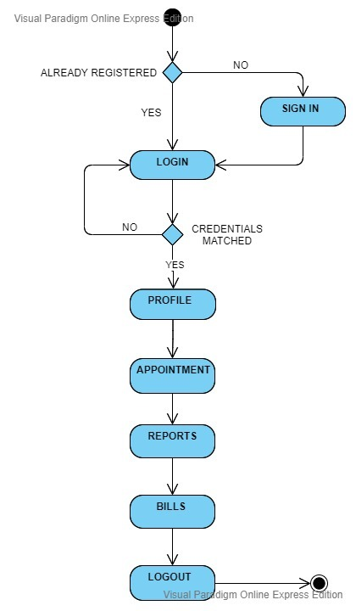

1. Activity Diagram (Doctor)

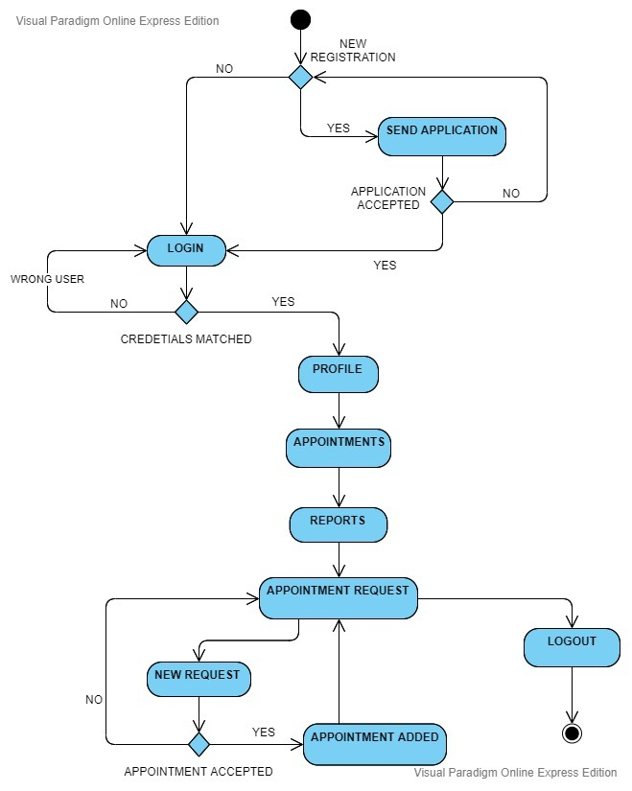

1. Activity Diagram (Administration)

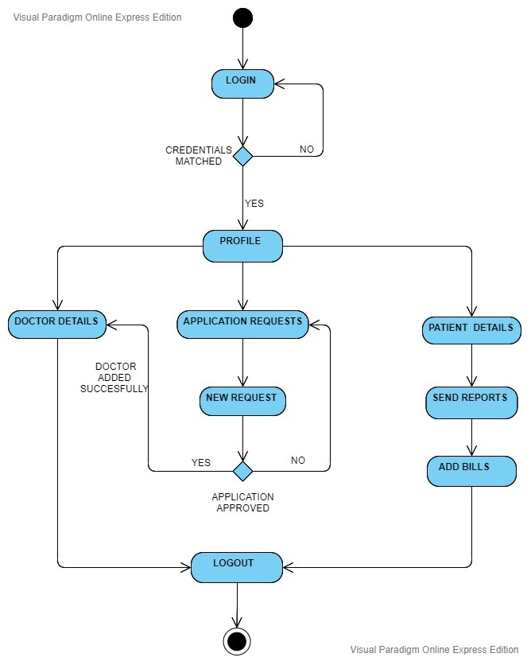

1. Use case diagram

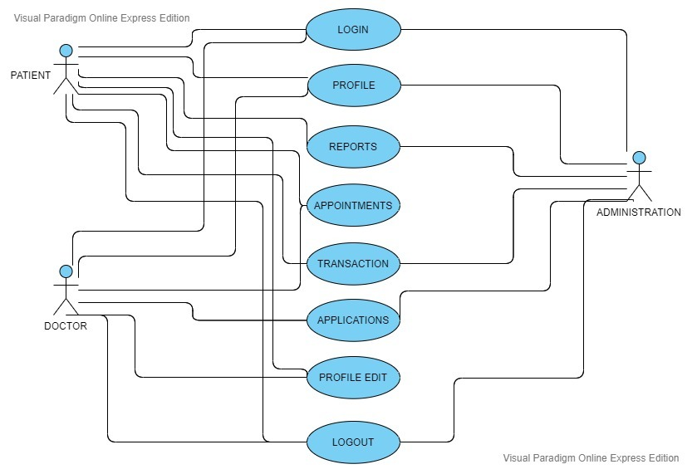

**Programming Code:**

All the files are contained in the zip file.

**Conclusion:**

Taking into account all the mentioned details, we can make the conclusion that the hospital management system is the inevitable part of the lifecycle of the modern medical institution. It automates numerous daily operations and enables smooth interactions of the users. Developing the hospital system software is a great opportunity to create the distinct, efficient and fast delivering healthcare model. Implementation of hospital management system project helps to store all the kinds of records, provide coordination and user communication, implement policies, improve day-to-day operations, arrange the supply chain, manage financial and human resources, and market hospital services. This beneficial decision covers the needs of the patients, staff and hospital authorities and simplifies their interactions. It has become the usual approach to manage the hospital. Many clinics have already experienced its advantages and continue developing new hospital management system project modules.